**Tableau Project**

**Name** : Disha Pravin Kolapkar

**Project Name** : Baseball Match Data Analysis

**Date** : 13-12-2024

**Technology** : Tableau

**Project Description** :

* Dashboard Title: "Baseball Match Data Analysis"
* Data Source: The dashboard appears to be based on baseball match data.
* **Key Visualizations**:
  + Bar Chart: Shows the count of home team runs and hits.
  + Line Chart: Compares home team runs against away team runs.
  + Pie Chart: Displays game attendance distribution across different climates.
  + Line Chart: Tracks monthly attendance trends.
  + Bar Chart: Shows the count of home team wins from away teams.
  + Table: Displays game attendance by day of the week.

**Analysis and Insights**:

* Home Team Performance:
  + The bar chart indicates the total number of runs and hits scored by the home team.
  + The line chart comparing home team runs to away team runs provides insights into the team's performance against opponents.
* Climate Impact:
  + The pie chart reveals the distribution of game attendance across different weather conditions. This could help identify optimal playing conditions for higher attendance.
* Attendance Trends:
  + The line chart tracking monthly attendance shows fluctuations throughout the season. This information can be valuable for planning and marketing strategies.
* Day of the Week Impact:
  + The table displaying game attendance by day of the week can help identify peak attendance days, which could inform scheduling decisions.
* Home Team Wins:
  + The bar chart showing the count of home team wins from away teams provides a direct measure of the team's success against opponents.

**Potential Report Sections**:

* Introduction:
  + Briefly introduce the purpose of the dashboard and the data it represents.
* Data Overview:
  + Summarize the key data points included in the dashboard.
* Visualizations and Analysis:
  + Describe each visualization in detail, explaining the insights it provides.
  + Discuss the relationships between different visualizations and the overall story they tell.
* Key Findings and Recommendations:
  + Highlight the most important findings from the analysis.
  + Based on the insights, suggest potential actions or recommendations for the baseball team or organization.
* Limitations and Future Considerations:
  + Acknowledge any limitations of the data or analysis.
  + Discuss potential areas for future exploration or data enhancement.

**Additional Considerations**:

* Context: Provide context about the data, such as the time period covered, the teams involved, etc.
* Target Audience: Tailor the report to the specific needs and interests of your audience.
* Storytelling: Use clear and concise language to tell a compelling story with the data.
* Visual Appeal: Ensure the report is well-formatted and visually appealing.

**Screenshots** :

*This is my project Dashboard* :

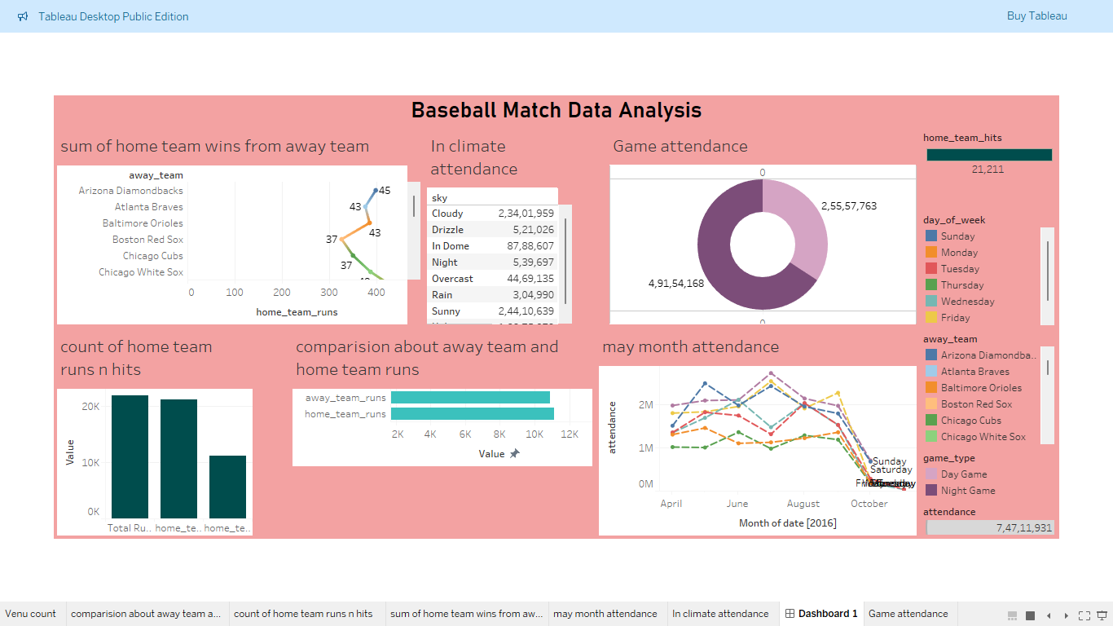

*This Bar Graph show the count of home team runs and hits* :

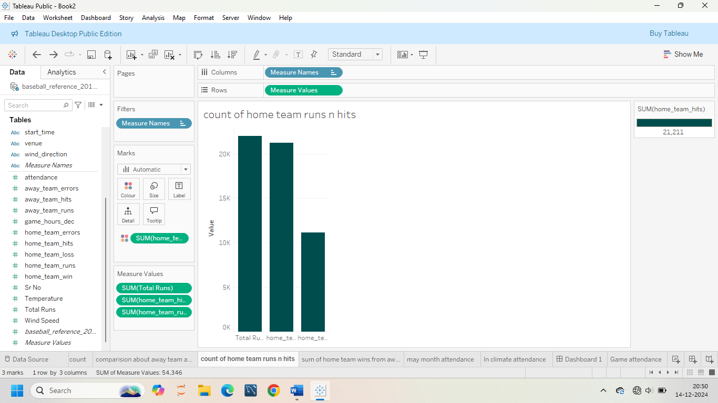

*This Donut Chart show the attendance of night game and day game* :

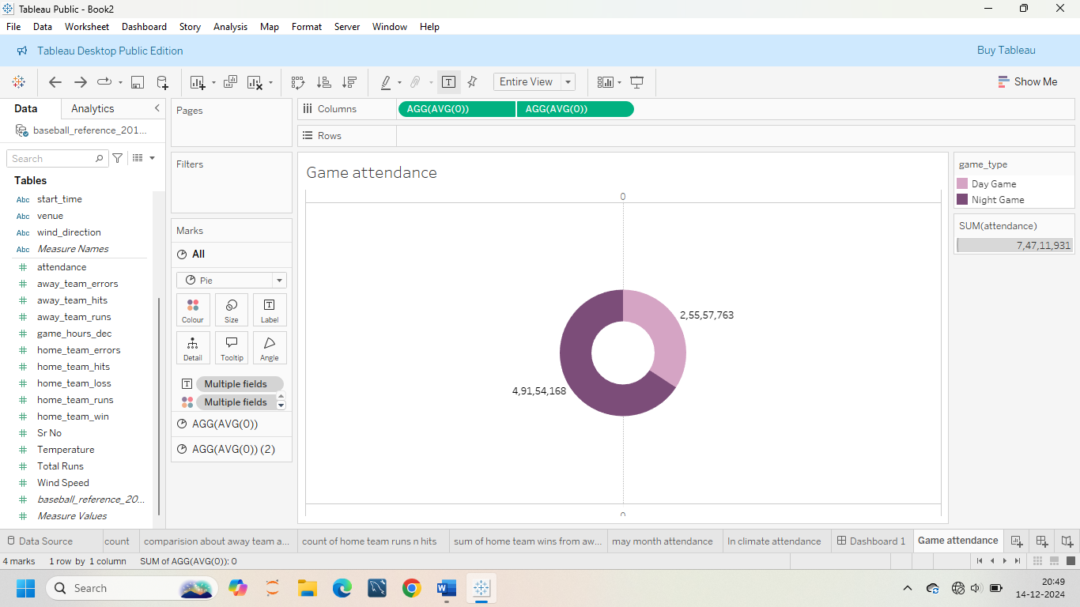

*This is count of venue to show in Tree maps* :

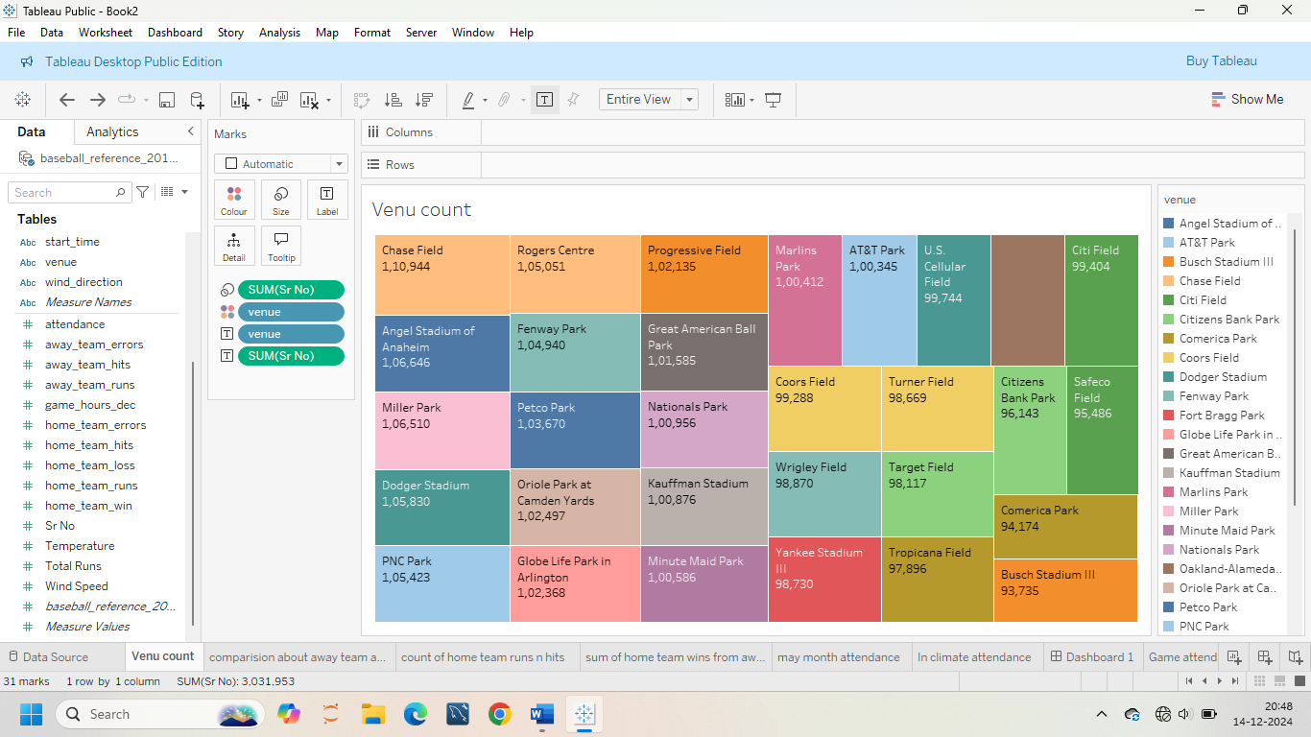

*This is the Line Graph to show the May Month attendance* :

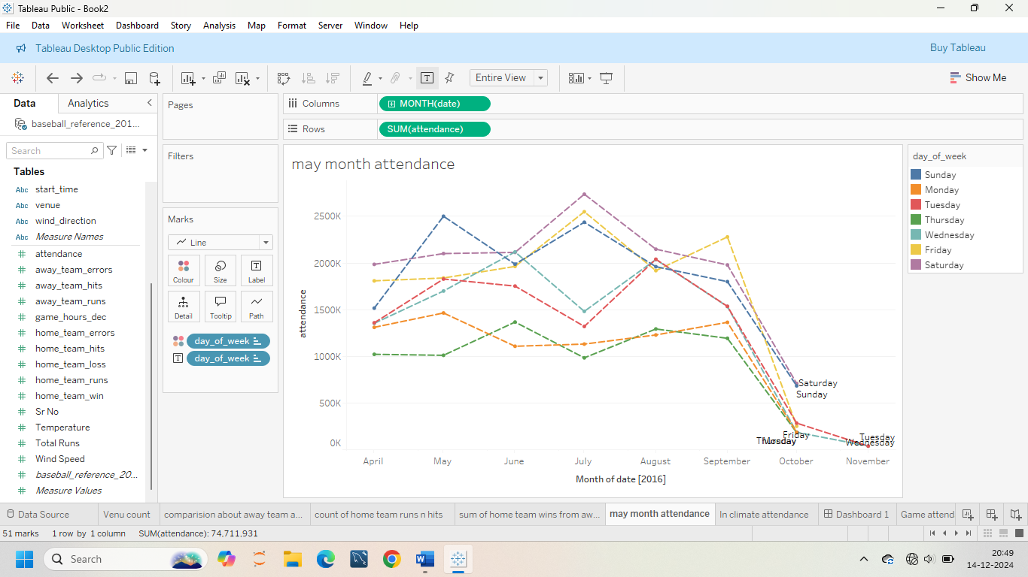

**Conclusion** :

In conclusion, this analysis of baseball match data reveals key insights into home team performance, attendance trends, and the impact of weather conditions. These findings can be used to inform strategic decisions regarding player performance, game scheduling, and fan engagement.